Software Requirement Specification Document

For

Vendor Risk Management Platform

Table of Contents: Pg.No:
1. Introduction4 - 8
  - Purpose
  - Intended Customers/ Users
  - Product Scope
  - Outline of the document

2. Overall Description9 - 14
2.1 Product Perspective
2.2 Product Functions
2.3User Classes
2.4 Design and Implementation Constraints

3. Diagrams15 - 27
3.1 UML Diagrams
3.2 ER Diagrams
3.3 DFD Diagrams
3.4 Assumptions and Dependencies

4. External Interface Requirement/Screenshots
4.1 User Interfaces
4.2 Hardware Interfaces
4.3 Software Interfaces
4.4 Communication Interfaces

5. Other Non-Functional Requirements
5.1Performance Requirements
5.2Safety Requirements
5.3 Security Requirements
5.4 Software Quality Attributes
5.5Business Policies/Rules (if any)

6. Testing
6.1 Block-Box Testing
6.2 White-Box Testing

7. Conclusion

8. References

9. Acknowledgements

Introduction
- Purpose:

        - The Vendor Risk Management Platform is developed to manage risks related to third-party vendors in an organized manner.

        - Many organizations currently handle vendor risk manually using spreadsheets and emails, which can lead to errors and delays.

        - This software helps centralize vendor information and improves visibility of vendor risks.

        - The SRS document explains what the system should do and how it should behave.

        - It clearly describes system requirements without discussing coding or implementation details.

- Intended Customers/Users:

        - Risk and compliance teams who assess and monitor vendor risks.
        - System administrators who manage users, roles, and configurations.
        - Vendor representatives who provide required information and documents.
        - Management teams who use reports to make informed decisions.

- Product Scope:

        - Allows onboarding and registrations of vendors.
        - Collects vendor risk and compliance-related information.
        - Performs high-level risk assessment of vendors.
        - Stores and tracks compliance documents.
        - Supports monitoring and reporting of vendor risks.

- Outline of the Document:

        - Introduction:
This section gives basic understanding of the project by explaining why the system is needed, who will use it, and what the software aims to achieve.
        - Overall Description:
This section explains how the system works in general, its operating environment, main features, and the different types of users involved.
        - Diagrams:
This section presents diagrams such as use case diagrams and system architecture diagrams to visually explain the structure and flow of the system.
        - External Interface Requirements/Screenshots:
This section describes how users interact with the system and shows sample screens or interfaces along with any external system interactions.
        - Other Non-Functional Requirements:
This section explains quality-related requirements such as system performance, security, usability, and reliability.
        - Testing:
This section describes how the system is tested, including basic test cases and methods used to verify that the requirements are met.
        - Conclusion:
This section summarizes the project work and highlights the importance and benefits of the developed system.
        - References:
This section lists the study materials, websites, and standards that were referred to during the project.
        - Acknowledgements:
This section thanks the faculty members, guides, and others who supported the project work.

Overall Description

- Product Perspective:

        - The Vendor Risk Management Platform is a standalone web-based system.
        - It can also be integrated as part of a largerorganizational risk or compliance system.
        - The system maintains its own centralized database for vendor and risk-related data.
        - It interacts with external systems such as:

            - Email services for sending notifications and alerts.

            - Document storage systems for storing compliance documents.

        - Example: The vendor Risk Management Platform may interact with an organization’s internal database to verify vendor details and control user access.

- Product Functions:

        - Vendor onboarding and registration.
        - Collection of vendor risk and compliance information.
        - Risk assessment and scoring based on defined criteria.
        - Uploading and tracking of vendor compliance documents.
        - Monitoring vendor risk status over time.
        - Sending alerts for high-risk vendors and expiring documents.
        - Generating summary and detailed risk reports for management.

- User Classes and Characteristics:

        - Vendor User:

            - Submit organization details.
            - Upload compliance and risk-related documents.
            - Respond to risk assessment questionnaires.

        - Risk/ Compliance User:

            - Review vendor information and documents.
            - Evaluate and monitor vendor risk levels.
            - Take action on high-risk vendors.
        - Administrator:

            - Manage users and access permissions.
            - Configure system settings and risk criteria.
            - Generate system-level reports.

- Design and Implementation Constraints:

a. Hardware Constraints:
            - System performance depends on server capacity and available storage.
b.Software Constraints:
1. Requires a modern web browser such as Chrome, Edge, or Firefox.
            - Depends on backend frameworks and database systems.
c. Regulatory Constraints:
1. Must follow basic data protection and organizational security policies.
d. Network Dependency:
1.Requires stable internet connectivity for proper functioning.
e. Database Constraints:
1. Database size may increase as the number of vendors and documents grows.
f. Browser Constraints:
1. Some features may vary slightly across different browsers.
g. Security Constraints:
1. Role-based access control must be enforced.
2. Sensitive data must be protected from unauthorized access.

Diagrams

  - UML Diagrams:
Module 1: User Management
- Description: The User Management module handles authentication and user account control within the Vendor Risk Management Platform. It supports login, password recovery, role assignment, and administrative user management while ensuring notifications are sent for critical user actions.

- Primary Actor: 1.User2.Admin3.Risk Analyst

- Secondary Actor:Notification Service

- Use Case Diagram:

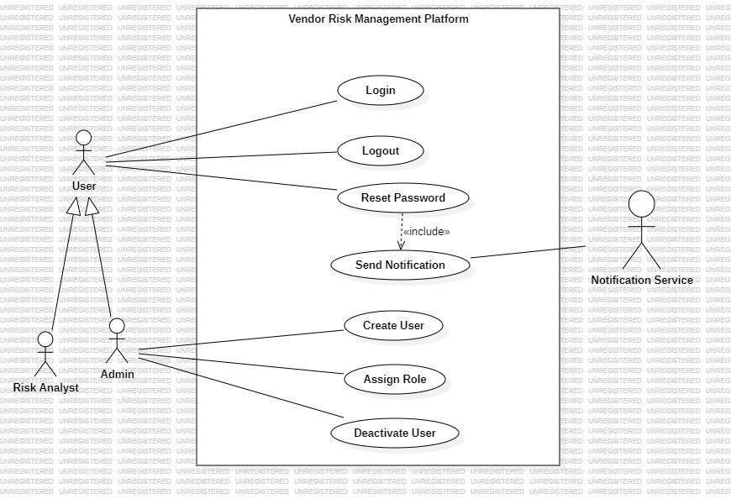
    - Use Case Diagram – User Management

Module 2: Vendor Management
- Description: The Vendor Management module manages vendor onboarding, profile maintenance, and document handling within the platform. It enables controlled activation and deactivation of vendors to ensure accurate and up-to-date vendor information.

- Primary Actors:
1. Vendor.
2. Admin.

- Secondary Actors:
1.None.

- Use Case Diagram:

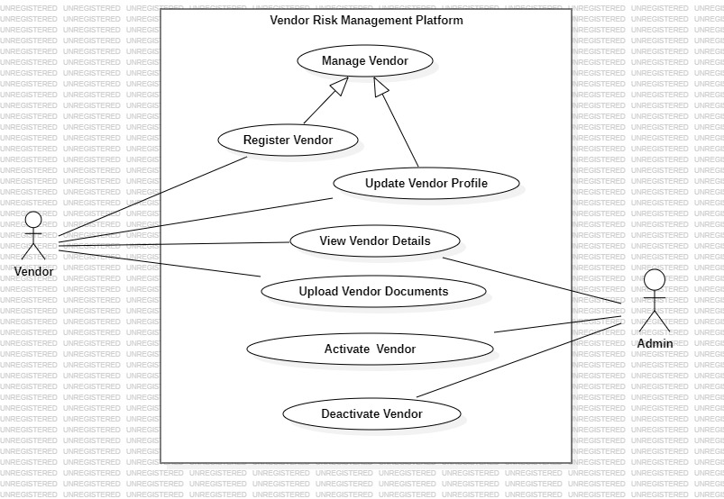
3.1.2 Use Case Diagram – Vendor Management

Module 3: Risk Assessment

- Description: The Risk Assessment module evaluates vendor risks using predefined criteria and scoring mechanisms. It supports continuous analysis of vendor risk levels to identify and monitor high-risk vendors.

- Primary Actor:
- Risk Analyst.

- Secondary Actor:
- External Risk Data Source.

- Use Case Diagram:

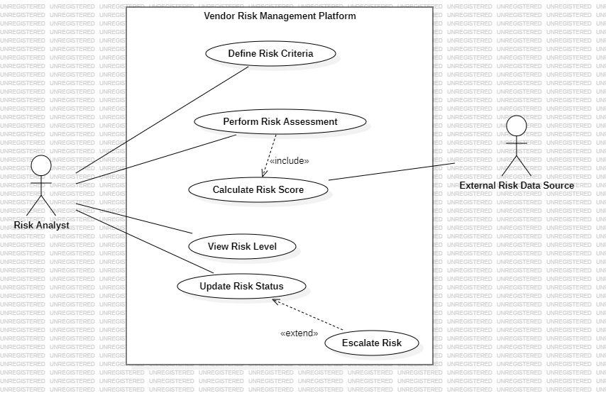
3.1.3 Use Case Diagram – Risk Assessment

Module 4: Compliance Management
- Description: The compliance Management module handles verification of vendor compliance by collecting required documents and supporting review and approval activities. It ensures vendors meet organizational and regulatory compliance standards.

- Primary Actor:
- Vendor.
- Risk Analyst.

- Secondary Actor:None.

- Use Case Diagram:

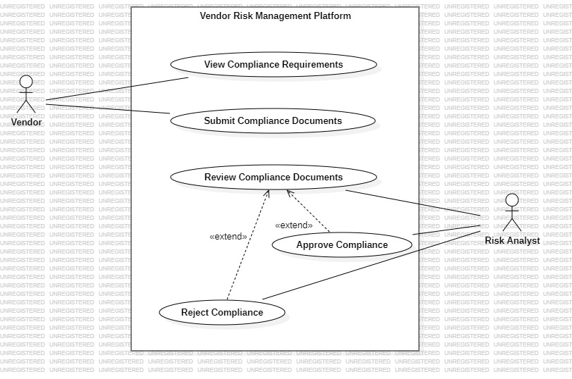
3.1.4 Use Case Diagram – Compliance Management

Module 5: Incident Management
- Description: The Incident and Issue Management module records, tracks, and resolves incidents related to vendor risks and operational issues. It supports timely updates, resolution actions, and stakeholder notifications to ensure effective handling of risk-related events.

- Primary Actor:
- Risk Analyst.
- Admin
3. Secondary Actor:
1.Notification Service.
4. Use Case Diagram:
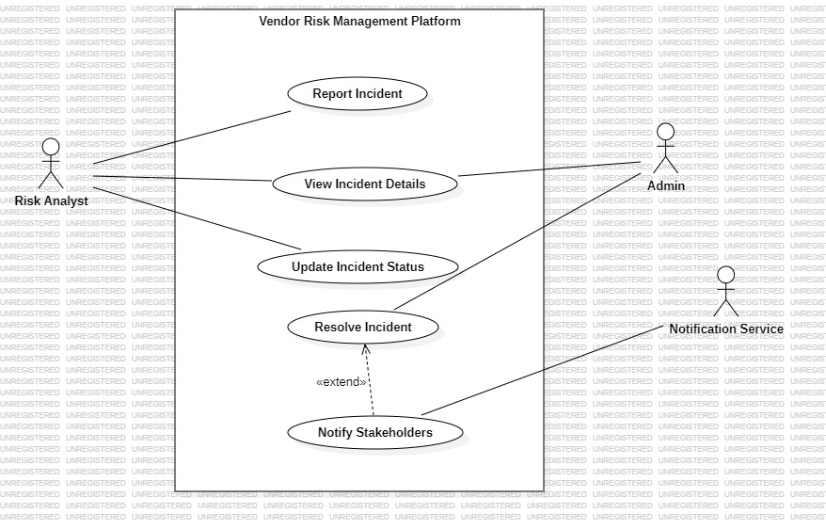3.1.5 Use Case Diagram – Incident & Issue Management

Module 6: Reporting and Dashboard
- Description: The Reporting and Dashboard module presents summarized risk information and generates reports to support monitoring and decision-making. It provides visual insights into vendor risk levels and system status.

- Primary Actor:
- Admin.
- Risk Analyst.

- Secondary Actor:
- None.

- Use Case Diagram:

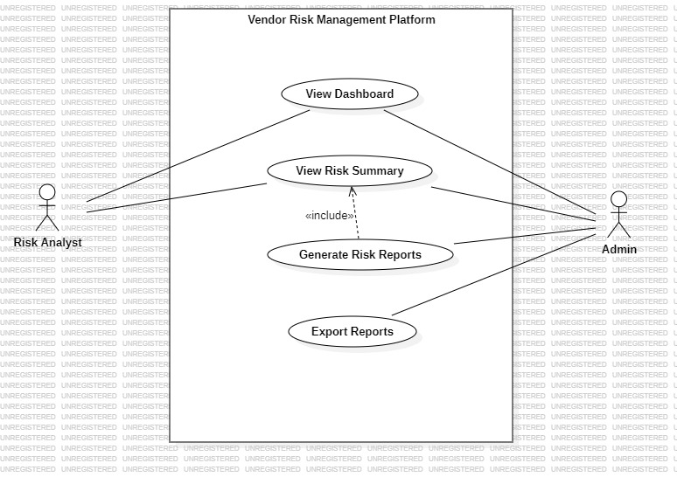
3.1.6 Use Case Diagram – Reporting & Dashboard

  - Class Relationships:
Module 1: User Management
Module Description: The user Management module handles authentication, authorization, and role-based access control in the system. It defines different user roles and supports system notification related to user activities.
Classes Involved:
1.User 2. Admin3. Risk Analyst4. Notification
Classes Relationships: The User class is generalized by Admin & Risk Analyst. User is associated with Notification.
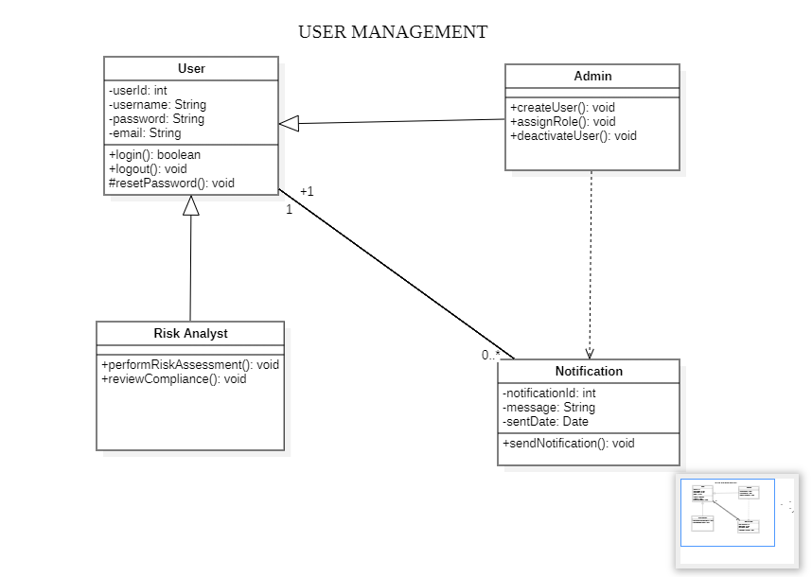

Module 2: Vendor Management
Module Description: The Vendor Management module manages vendor information, profiles, documents, and categorization. It ensures structured storage of vendor-related data.
Classes Involved:
1. Vendor 2. Vendor Profile 3. Vendor Document
4. Vendor Category
Classes Relationship: Vendor has a composition relationship with Vendor Profile and Vendor Document, indicating strong ownership. Vendor is associated with Vendor Category to classify vendors based on category.
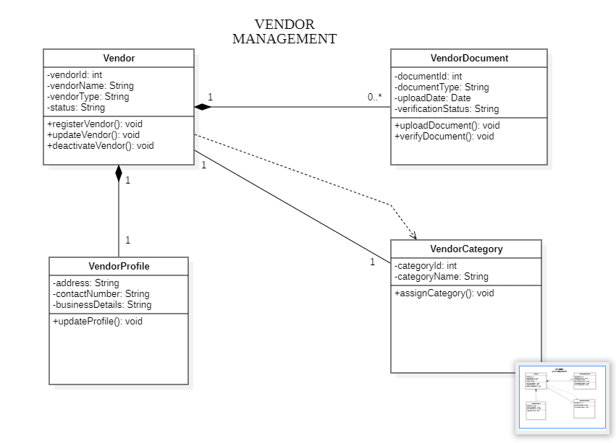

Module 3: Risk Assessment
Module Description: The Risk Assessment module evaluates vendor risk using predefined criteria and scoring mechanisms. It supports systematic risk evaluation and classification.
Classes Involved:
1.Risk Assessment 2. Risk Criteria 3. Risk Score
4. Risk Matrix
Classes Relationship: Risk Assessment Aggregates Risk Criteria for evaluation. Risk Assessment is associated with Risk Score to store calculated results. Risk Score depends on Risk Matrix to determine risk levels.
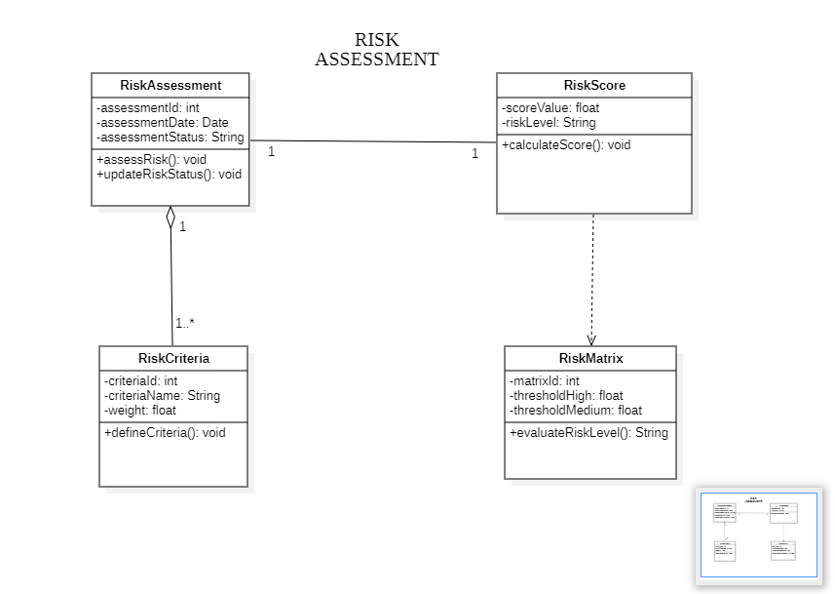
Module 4: Compliance Management
Module Description: The Compliance Management module ensures vendors adhere to defined policies and standards. It tracks compliance status and maintains audit history.
Classes Involved:
1. Compliance Record 2. Compliance Policy 3. Compliance Status 4. Audit Log
Classes Relationship: Compliance Record aggregates Compliance evaluation. It is associated with Compliance Status to represent compliance state and composed with Audit Log to maintain audit history.
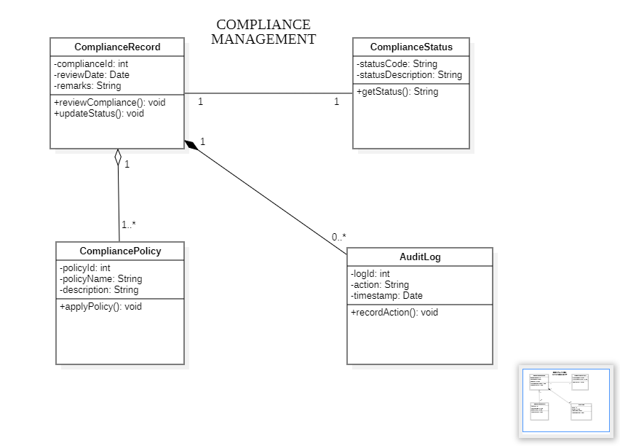

Module 5: Incident Management
Module Description: The Incident Management module manages identification, reporting, and resolution of incidents. It supports severity classification and response tracking.
Classes Involved:
1. Incident 2. Incident Report 3. Incident Severity
4. Incident Response
Classes Relationship: Incident is composed with Incident Report to capture incident details. Incident is associated with Incident Severity for classification and has a dependency relationship with Incident Response for corrective actions.
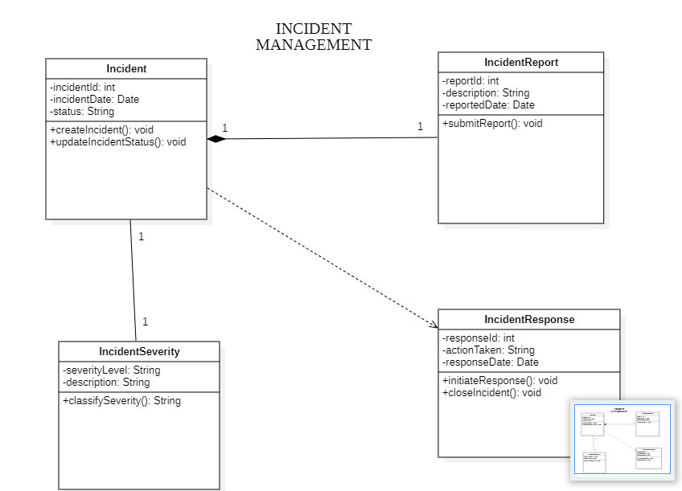

Module 6: Reporting and Dashboard
Module Description: The Reporting and Analytics module generates reports and dashboards to support decision-making. It presents analytical insights in a structured format.
Classes Involved:
1. Report 2.Report Template 3. Analytics Data
4. Dashboard
Classes Relationship: Report is composed with Report Template to define report structure. Report is associated with Analytics Data as its data source. Dashboard depends on Report to display generated insights.
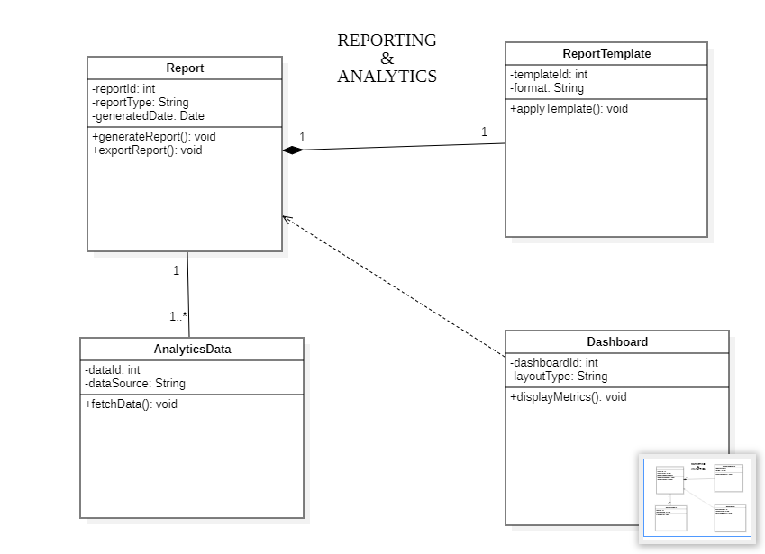

State Diagrams- vendor Management:

- State Diagram – Vendor:
- Object - Vendor
Description: This state diagram illustrates the life cycle of the vendor class. It shows how a vendor moves from creation to verification, activation, and deactivation based on system events.
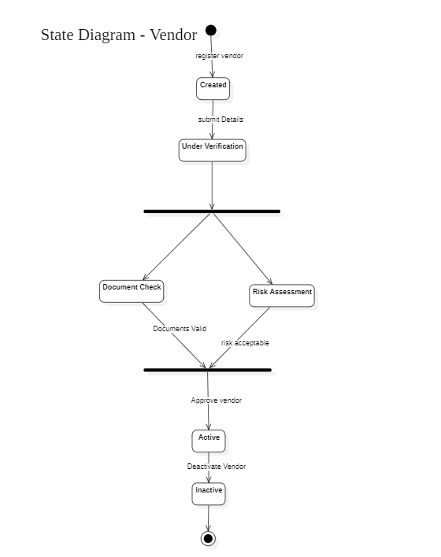

- State Diagram – Vendor Profile:
- Object – Vendor Profile
Description: This state diagram represents the life cycle of the Vendor Profile class, including profile creation, updates, validation and approval.

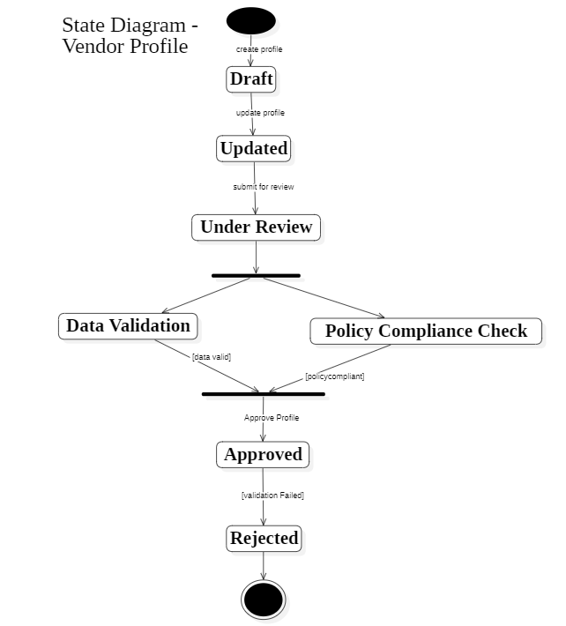

- State Diagram - Vendor Document:
- Object – Vendor Document
Description: This state diagram shows the states involved in vendor document handling, including upload, parallel validation, verification, and rejection using guard conditions.

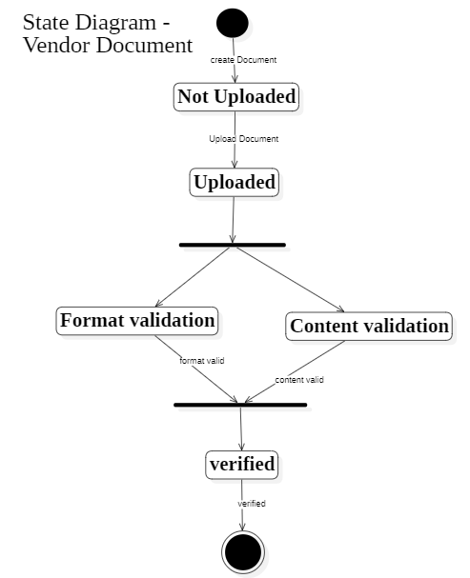

- State Diagram - Vendor Category:
- Object – Vendor Category
Description: This state diagram represents the category assignment process for vendors, including assignment, modification, and removal.

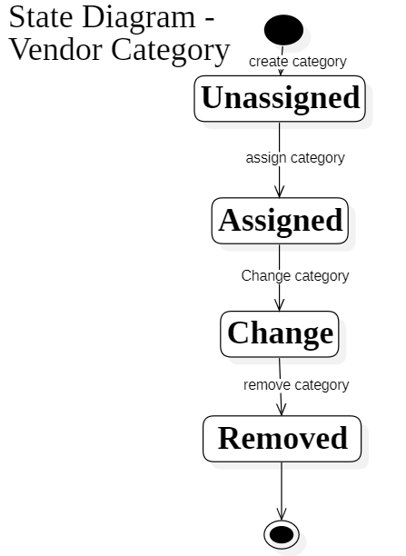

3.4 Activity Diagrams:
- Vendor Management:
Description: This activity diagram illustrates the workflow of vendor onboarding, including registration, profile submission, document verification, risk assessment, and vendor activation.

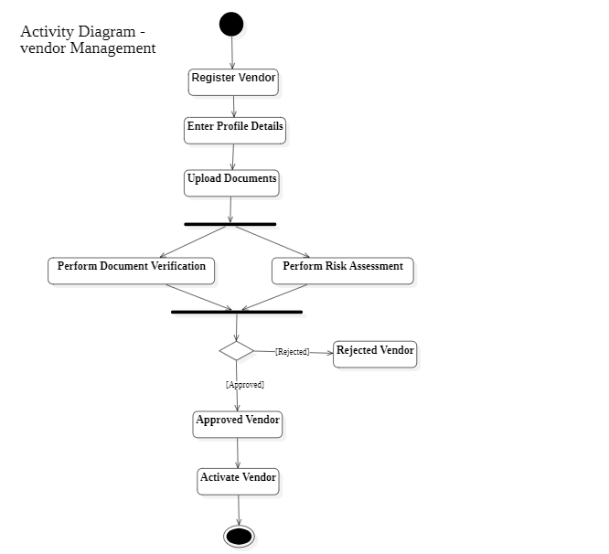

- Incident Management:
Description: This activity diagram represents the workflow of incident handling, including incident reporting, investigation, resolution, and closure.

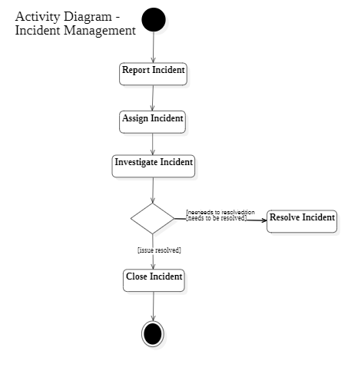

3.5. Sequence Diagrams
Module: User Management
Description: This sequence diagram shows the interaction between the user and system components during the login process. It explains how the user submits credentials, how the authentication system verifies them with the database, how the system returns the login result to the user.
Objects:
  - User - Login Interface - Authentication System
  - Database - Notification Service
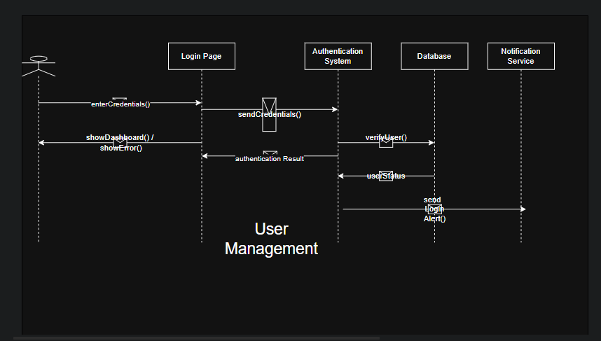

Module: Vendor Management
Description: This sequence diagram illustrates the vendor registration process. It shows how vendor details are submitted through the vendor portal, stored in the system database, and reviewed by the administrator for approval.
Objects:
  - Vendor - Vendor Portal - Vendor Management System
  - Database - Admin
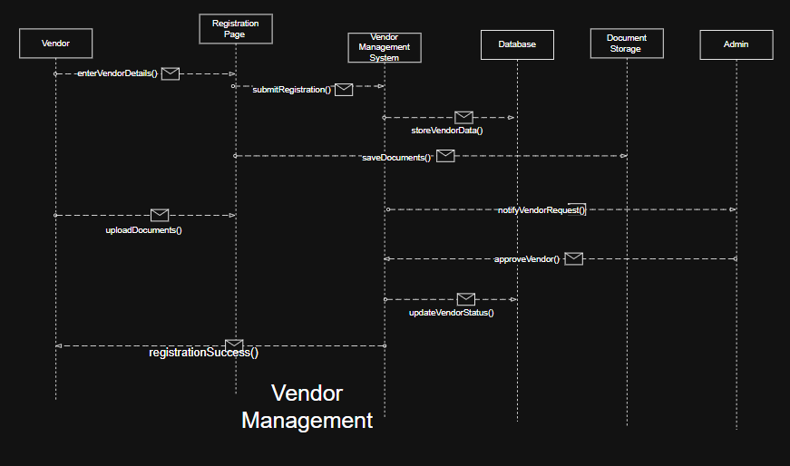

Module: Risk Assessment
Description:This sequence diagram represents the process of evaluating vendor risk. It shows how the risk analyst initiates the assessment, how vendor data is analyzed using risk criteria, and how the calculated risk score is stored and reported.
Objects:
  - Risk Analyst - Risk Assessment Module - Risk Criteria Engine - Risk Matrix - Database - Reporting System
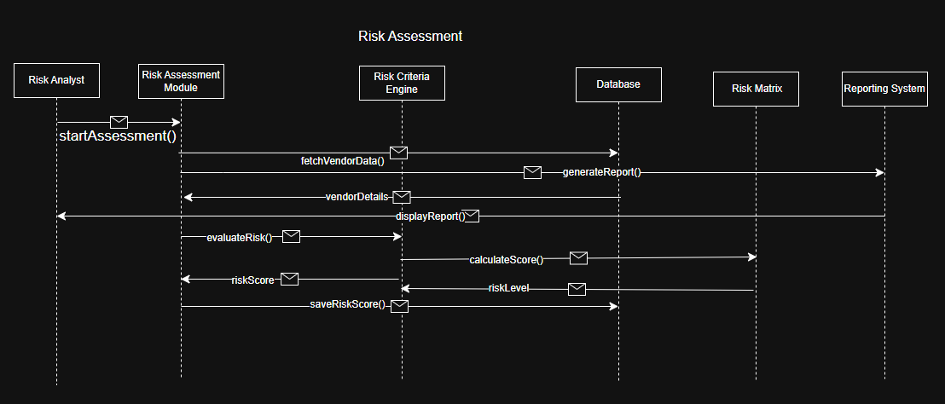
3.6. Collaboration Diagram

Module: User Management
Description: This collaboration diagram shows the interaction between system components during the user login process. It illustrates how the user communicates with the login interface, authentication system, and database to verify credentials and access the system.

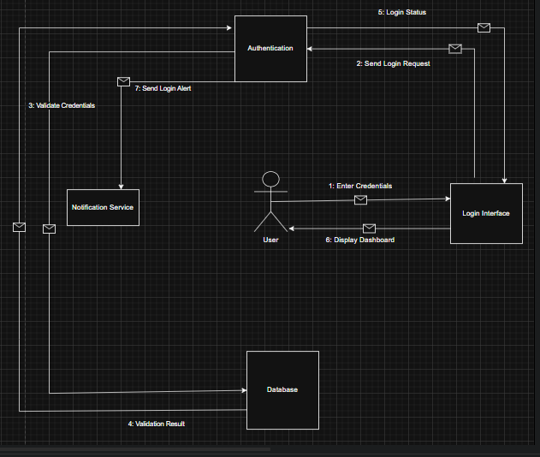

Module: Vendor Management
Description: This collaboration diagram illustrates how different components interact during vendor registration and onboarding. It shows how vendor details and documents are submitted through the vendor portal, stored in the system, and approved by the administrator.

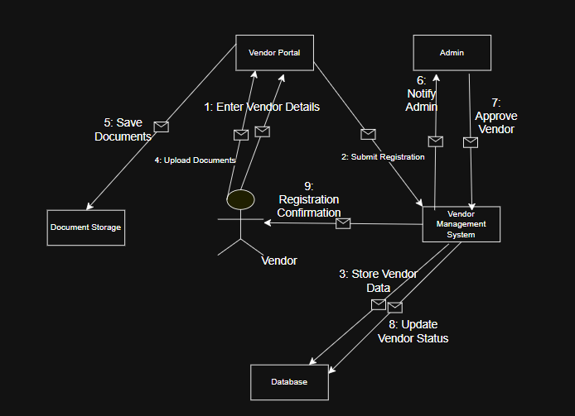

Module: Risk Assessment
Description:This collaboration diagram represents the interaction between system modules during the vendor risk evaluation process. It shows how the risk analyst initiates assessment and how the system calculates and stores the vendor risk score.

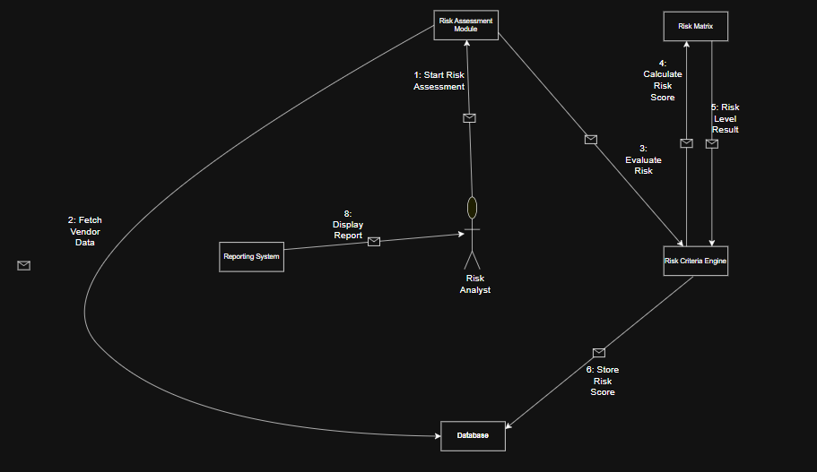

3.7ER Diagram:
Description:This ER diagram represents the data structure of the vendor Risk Management Platform. It illustrates the main entities such as User, Vendor, Risk assessment, Compliance Record, Vendor Document, and Incident, along with their attributes and relationships. The diagram shows how vendor information is stored and how different modules interact with the database.
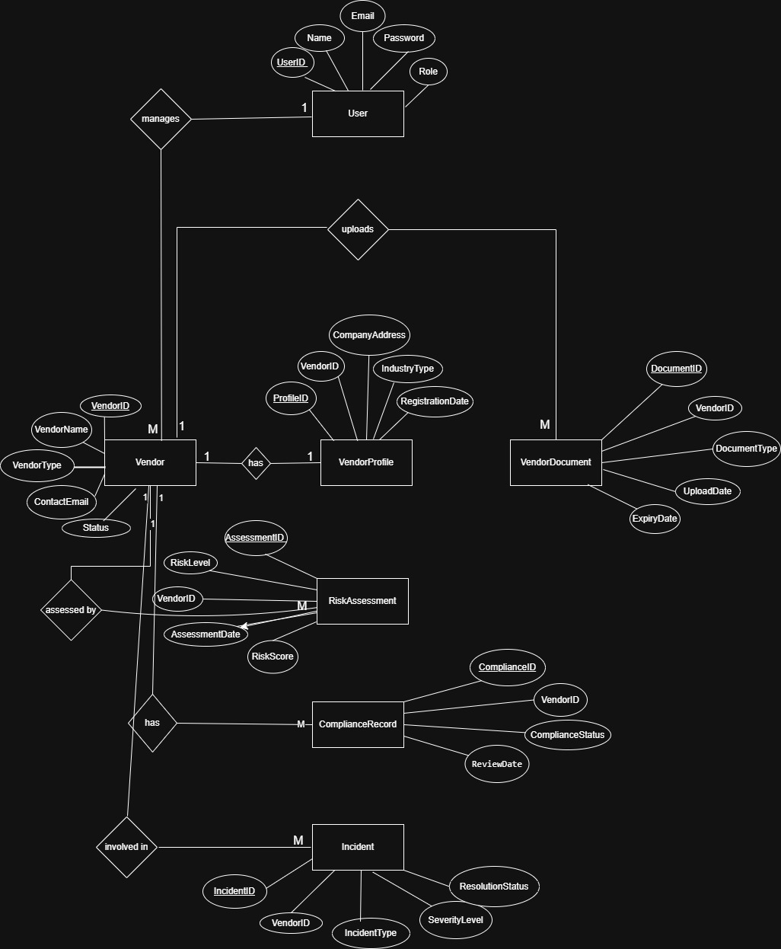

3.8 DFD Diagrams:
Description:The level-1 Data Flow Diagrams represents the detailed breakdown of the main processes in the Vendor Risk Management Platform. It shows how data flows between external entities, System processes, and data stores. The diagram explains how vendor information is collected, risk assessments are performed, compliance documents are managed, and reports are generated.
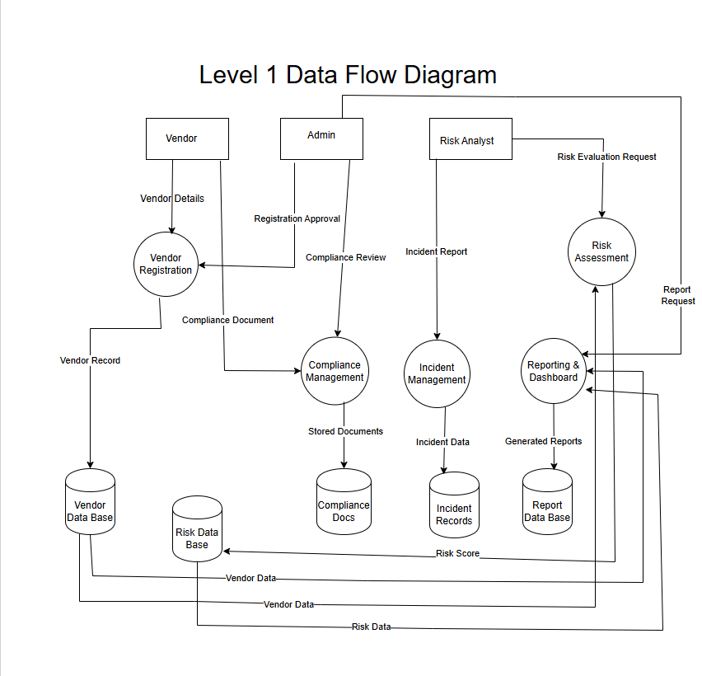

External Interface Requirement

This section describes how the vendor risk management platform interacts with users, hardware devices, other software systems, and communication networks. It defines the interfaces required for the system to function properly and exchange data with external components.
4.1 User Interfaces:
This Vendor Risk Management Platform provides a web-based graphical user interface(GUI) that allows administrators, risk managers, and vendors to interact with the system. The interface is designed to be user-friendly and accessible through standard web browsers.
Main user interface screens include:
1. Login Page – Allows users to log in using username and password authentication.
2. Dashboard – Displays vendor risk statistics, alerts, and system notification.
3. Vendor Registration Screen – Enables vendors to submit company details and profile information.
4. Risk Assessment Page – Allows risk managers to evaluate vendor risks and assign risk scores.
5. Compliance Document Upload Page – Vendors can upload compliance certificates and security documents.

4.2 Hardware Interfaces:
The system does not require any specialized hardware devices. It operates using standard computing devices such as desktop computers, laptops, tablets, or smartphones with internet access.
Supported hardware components include:
- Client Devices (PC, laptop, mobile device).
- Server hosting the application.
- Network devices such as routers and switches.
Hardware interface requirements describe how software interacts with physical devices and system hardware.
4.3 Software Interfaces:
The Vendor Risk Management Platform interacts with several external software systems and technologies to ensure proper functionality.
Software components include:
- Operating System: Windows/Linux Server.
- Data System: MySQL or PostgreSQL database for storing vendor and risk data.
- Web Browser: Google Chrome, Mozilla Firefox, Microsoft Edge.
- Authentication Services: Secure login and access control modules.
- Risk Assessment Tools: External frameworks used to evaluate vendor security risks.
- Software interfaces define how the system connects with other software systems, databases, and applications.
4.4Communication Interfaces:
The Vendor Risk Management Platform communicates with users and external systems through secure network protocols.
Communication methods include:
- HTTP/HTTPS protocols for web communication.
- Secure data transmission using encryption(SSL/TLS).
- Email notifications for alerts, approvals, and risk reports.
- API communication for integration with external compliance tools.
- Communication interface requirements specify the protocols and network mechanisms used for system communication.

Other Non-Functional Requirements
This section describes the non-functional requirements of the Vendor Risk Management Platform. These requirements define how the system performs and the constraint under which it operates, including performance, safety, security, and overall software quality.
5.1 Performance Requirements:
This Vendor Risk Management Platform should operate efficiently and provide quick responses to user requests. The system must support multiple users accessing the platform simultaneously without performance degradation.
The platform should process vendor registrations, risk assessments, and document uploads within a reasonable response time.
Ex 1: The system should load dashboard information within 3 seconds after user login.
Ex 2: The system should allow multiple vendors to upload documents simultaneously without system slowdown.
5.2 Safety Requirements:
This system must ensure that vendor data and risk assessment information are handled safely and accurately. Proper backup and error-handling mechanisms should be implemented to prevent data loss or system failure.
The platform should also prevent incorrect or incomplete data from affecting risk evaluation processes.
Ex 1: The system should maintain regular database backups to prevent data loss.
Ex 2: The system should display error messages if invalid data is entered during vendor registration.
5.3 Security Requirements:
The Vendor Risk Management Platform must ensure access and protect sensitive vendor information. User authentication and authorization mechanism should be implemented to restrict access based on roles such as administrator, risk manager, and vendor.
Sensitive data should be protected using encryption and secure communication protocols.
Ex 1: Only authorized administrators can approve vendor risk assessments.
Ex 2: User login credentials must be encrypted and stored in the database.
5.4 Software Quality Attributes:
This system should maintain high software quality standards to ensure reliability, and maintainability. The platform must be easy to use, scalable, and capable of handling future system updates.
The application should also provide consistent performance and minimize system errors.
Ex 1: The system should provide a user-friendly interface for vendors and administrators.
Ex 2: The platform should allow future enhancements such as integration with additional compliance tools.
5.5 Business Policies/Rules:
The Vendor Risk Management Platform should follow predefined organizational rules for vendor evaluation and risk assessment. These rules ensure that vendors are assessed according to standardized procedures.
Risk classification and approval processes must follow the organization’s vendor risk management policies.
Ex 1: Vendors must submit required compliance documents before risk evaluation can be completed.
Ex 2: Vendor with high risk scores must undergo additional review before approval.

Testing
I selected the Vendor Risk Evaluation functionality from my project for testing. This function allows administrators to evaluate vendors based on factors such as security score, compliance status, incident history, and financial stability. The function validates the input data, processes the vendor information, and calculates the overall risk level. Based on the evaluation results, the system returns different outputs such as Low risk, Medium Risk, High Risk, or invalid input when incorrect data is provided.
Sample Code:
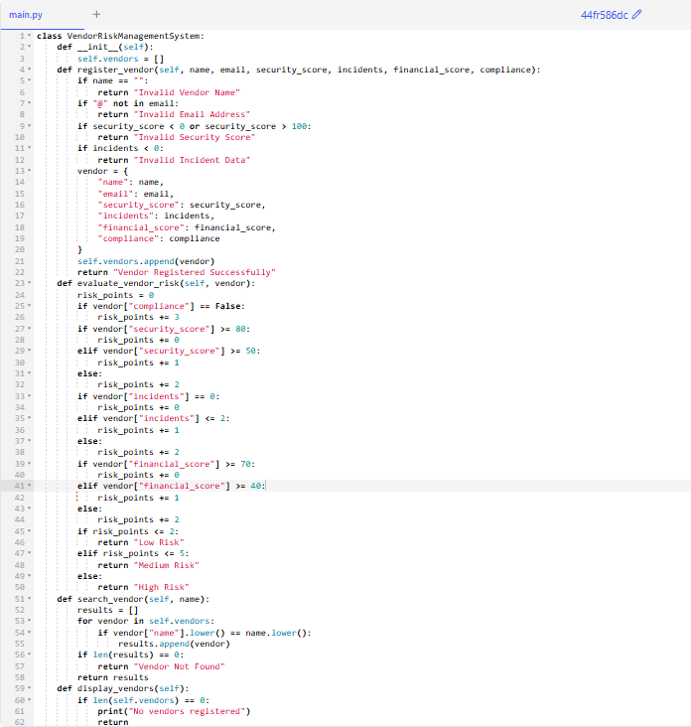
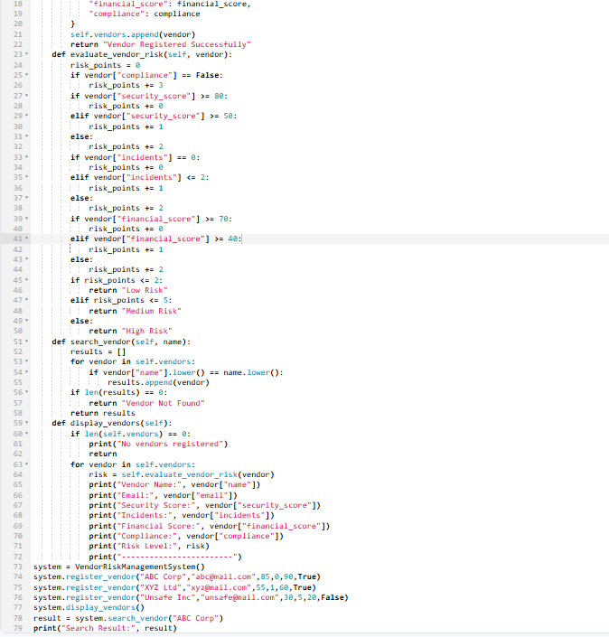
White Box Testing:
- Start
- Initialize System
- Validate Vendor Name
- Name Valid?
- Invalid Name
- Validate Email
- Email Valid?
- Validate Security Score
- Security Score Decision
- Incident Evaluation
- Financial Score Evaluation
- Low Risk
- Medium Risk
- High Risk
- End
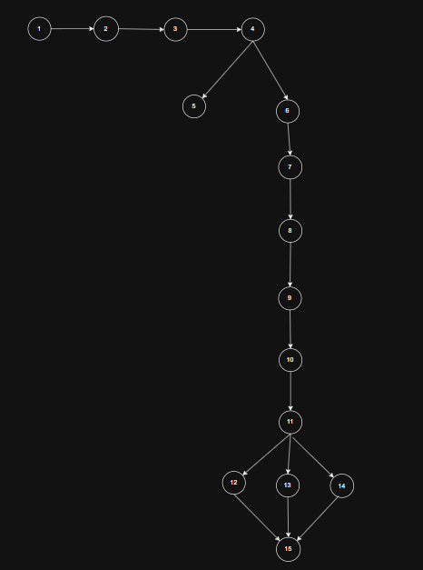

2. Cyclomatic Complexity:
Method 1: Using Regions
From the CFD of the Vendor Risk Evaluation Module:
Number or regions=6. Therefore, Cyclomatic Complexity = 6.
Method 2: Using Edges and Nodes
V(G) = E – N + 2
From the Control Flow Diagram:
Edges (E) = 16
Nodes (N) = 12
V(G) = 16 – 12 + 2
Therefore, Cyclomatic Complexity V(G) = 6
Method 3: Using Predicate Nodes
V(G) = P + 1
Decision nodes in the program:
- Vendor name validation
- Email validation
- Security score validation
- Incident validation
- Risk classification decision
P = 5
Cyclomatic Complexity, V(G) = 5 + 1 => 6
3. Independent Paths:
Path no | Independent  Path | Test Input | Expected  Output
P1 | 1 → 2 → 3 → 4 → 5 → 15 | Vendor name = "" | Invalid Vendor Name
P2 | 1 → 2 → 3 → 4 → 6 → 7 → 15 | Email = "abc.com" | Invalid Email Address
P3 | 1 → 2 → 3 → 4 → 6 → 7 → 8 → 9 → 15 | Security Score = 120 | Invalid Security Score
P4 | 1 → 2 → 3 → 4 → 6 → 7 → 8 → 9 → 10 → 15 | Incidents = -1 | Invalid Incident Data
P5 | 1 → 2 → 3 → 4 → 6 → 7 → 8 → 9 → 10 → 11 → 12 → 15 | security_score = 85, incidents = 0, financial_score = 90 | Low Risk
P6 | 1 → 2 → 3 → 4 → 6 → 7 → 8 → 9 → 10 → 11 → 13 → 15 | security_score = 60, incidents = 1, financial_score = 50 | Medium Risk
P7 | 1 → 2 → 3 → 4 → 6 → 7 → 8 → 9 → 10 → 11 → 14 → 15 | security_score = 30, incidents = 5, financial_score = 20 | High Risk
Minimum number of test cases required = 6
4. Unit Testing:
Code 1:
import unittest
class TestVendorLowRisk(unittest.TestCase):
deftest_low_risk(self):
system = VendorRiskManagementSystem()
system.register_vendor(
"ABC Corp",
"abc@mail.com",
85,
0,
90,
True
)
vendor = system.vendors[0]
result = system.evaluate_vendor_risk(vendor)

self.assertEqual(result, "Low Risk")
if __name__ == "__main__":
unittest.main()
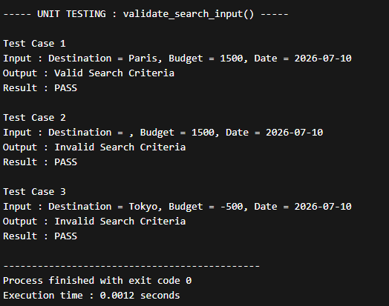
Code 2:
import unittest
class TestVendorHighRisk(unittest.TestCase):
deftest_high_risk(self):
system = VendorRiskManagementSystem()
system.register_vendor(
"Unsafe Inc",
"unsafe@mail.com",
30,
5,
20,
False
)
vendor = system.vendors[0]
result = system.evaluate_vendor_risk(vendor)
self.assertEqual(result, "High Risk")
if __name__ == "__main__":
unittest.main()
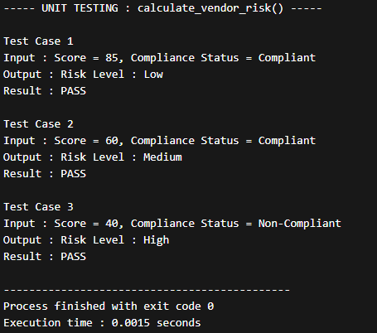
Black Box Testing:
- Functional Requirements:
Functional Requirement ID | Description
FR1 | System should accept vendor risk score as input
FR2 | System should accept vendor compliance status
FR3 | System should classify risk level (Low, Medium, High)
FR4 | System should display appropriate error message for invalid inputs
- Equivalence Partitioning:
Partition | Input Range | Type
P1 | Score < 0 | Invalid
P2 | 0 - 50 | Valid
P3 | 51 - 75 | Valid
P4 | 76 – 100 | Valid
P5 | Score > 100 | Invalid
- Compliance Status:
Partition | Value | Type
P6 | Compliant | Valid
P7 | Non-Compliant | Valid
P8 | Other Values | Invalid
- Boundary Value Analysis:
BB NO | Test Input(Score,  Compliance) | Expected  Output | Technique
BB1 | Score = -1, Compliant | Invalid Input | Below lower boundary
BB2 | Score = 0, Compliant | Risk Level: High | Lower boundary
BB3 | Score = 1, Compliant | Risk Level: High | Just above lower boundary
BB4 | Score = 50, Non-Compliant | Risk Level: High | Upper boundary of High Risk
BB5 | Score = 51, Compliant | Risk Level: Medium | Just above boundary
BB6 | Score = 75, Compliant | Risk Level: Medium | Upper boundary of Medium Risk
BB7 | Score = 76, Compliant | Risk Level: Low | Just above boundary
BB8 | Score = 100, Compliant | Risk Level: Low | Maximum boundary
BB9 | Score = 101, Compliant | Invalid Input | Above maximum boundary
- Testing few test cases:
Code:
defcalculate_vendor_risk(score, compliance):

if score < 0 or score > 100:
return "Invalid Input"

if compliance == "Non-Compliant":
return "Risk Level: High"

if score <= 50:
return "Risk Level: High"

elif score <= 75:
return "Risk Level: Medium"

else:
return "Risk Level: Low"

# Test cases
print("Test Case 1:", calculate_vendor_risk(85, "Compliant"))
print("Test Case 2:", calculate_vendor_risk(60, "Compliant"))
print("Test Case 3:", calculate_vendor_risk(40, "Non-Compliant"))
print("Test Case 4:", calculate_vendor_risk(-5, "Compliant"))

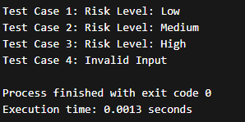
Conclusion:
The Software Requirements Specification(SRS) document provide a clear description of the vendor risk Management Platform and its major functionalities. It explains the overall structure of the system, including user management, vendor management, and risk assessment modules. The document also presents the system design using UML diagrams such as use case diagrams, sequence diagrams, and collaboration diagrams. These diagrams help in understanding how different components of the system interact with each other.
The main objective of this system is to support organizations in identifying, evaluating, and managing vendor-related risks effectively. By organizing vendor information and risk assessment processes, the system can improve decision-making and reduce operational risks. This SRS document serves as a guideline for the development and implementation of the proposed system.
In addition, the documentation helps developers, designers, and stakeholders understand the system requirements clearly before the implementation phase begins. Proper documentation ensures that the system development process becomes more organized and systematic. Overall, the Vendor Risk Management System aims to provide a reliable platform for monitoring vendor activities and managing potential risks efficiently.
References:
- IEEE Computer Society, IEEE Recommended Practice for Software Requirements Specifications (IEEE 830 Standard).
- Ian Sommerville, Software Engineering, 10th Edition, Pearson Education.
- Roger S. Pressman, Software Engineering: A Practitioner’s Approach, McGraw-Hill Education.
- Grady Booch,JamesRumbaugh, and Ivar Jacobson, The Unified Modelling Language User Guide, Addison-Wesley.
- Object Management Group, Unified Modelling Language ( UML) Documentation.
- IEEE Digital Library resources.
- Course lecture materials and class motes provided by the instructor.
- Online UML tutorials and documentation used for understanding modelling concepts.
Acknowledgements:
I would like to express my sincere gratitude to our course instructor for their valuable guidance and continuous support throughout the preparation of this Software Requirements Specification. Their suggestions and feedback helped improve the quality of this projects.
I prepared this SRS document by applying the concepts taught during the course. The guidance provided in the classroom helped me organise the project structure, identify the system modules, and develop the required diagrams and documentation.

Design Architecture of System

- Component-Level Design Elements:
The design architecture describes the overall structure of the vendor risk management system. It explains how the software components are organized and how the system is deployed in the computing environment. This architecture helps in understanding the interaction between modules and system elements.
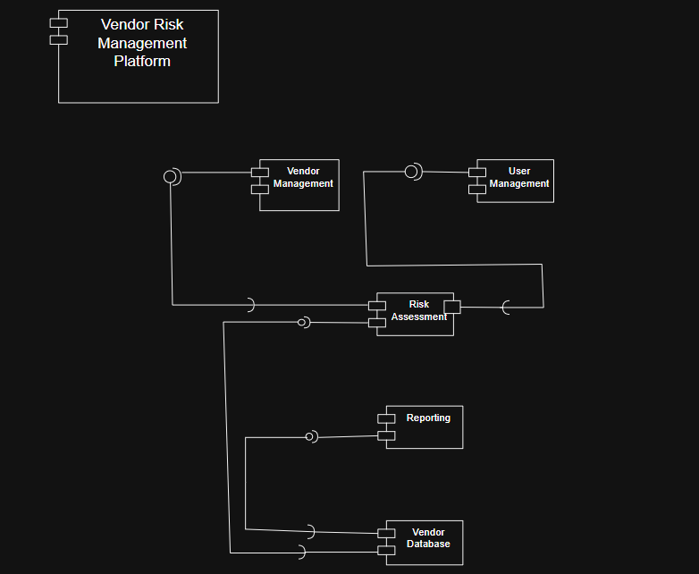

- Deployment-Level Design Element:
The component diagram represents the major software components of the vendor risk management platform and their relationships. It shows how different modules such as user management, vendor management, risk assessment, and reporting interact with each other. These components work together to process user requests and manage vendor risk data.
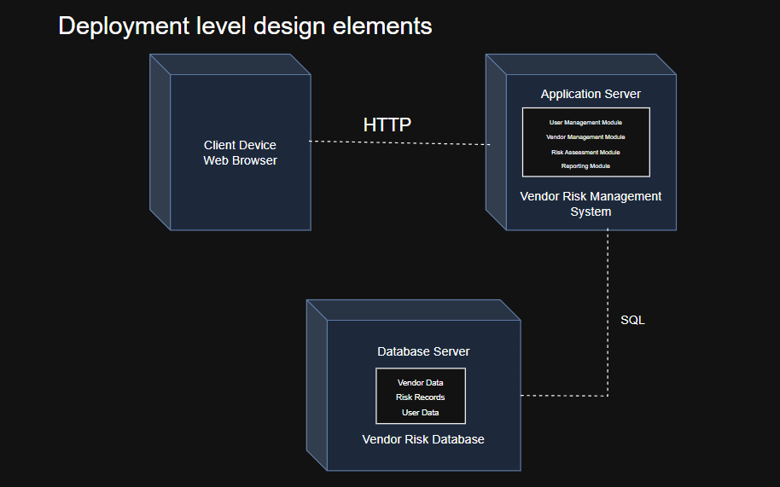
Product Metrics

Introduction:
Product metrics are used to measure the size, complexity, and quality of the vendor risk management platform. These metrics help in estimating the effort, time, cost, and the number of defects in the system.
Function Point Analysis(FPA) is used in this project to evaluate the functional size of the system based on user interactions and system characteristics.
The calculation involves the following steps:
- Identification of Information Domain Values.
- Calculation of Unadjusted Function Points(UFP).
- Calculation of Complexity Adjustment Factor(CAF).
- Calculation of Function Points(FP).

Identification of Information Domain Values:
The following values are identified based on the system modules:
External Inputs (EI):
- Vendor Registration
- User Login
- Risk Assessment Input
- Compliance Document Upload
- Incident Reporting
- Vendor Profile update
Total External Inputs(EI) = 6

External Outputs (EO):
- Risk Reports
- Dashboard Display
- Alerts and Notifications
- Incident Reports
- Compliance status reports
Total External Outputs(EO) = 5
External Inquiries (EQ):
- View Vendor Details
- Search Vendor
- View Risk Status
- View Compliance Status
Total External Inquiries(EQ) = 4
Internal Logical Files (ILF):
- Vendor Database
- Risk Assessment Records
- Compliance Records
- Incident Records
- User Data
Total Internal Logical Files(ILF) = 5
External Interface Files (EIF):
- Email Notification System
- External Risk Data Source
- Compliance APIs
Total External Interface Files(EIF) = 3

Unadjusted Function Points(UFP):

Information Domain Value | Count | Weighting Factor  Simple Average Complex | Total
External Inputs(EI) | 6 | 3 4 6 | 24
External Outputs(EO) | 5 | 4 5 7 | 25
External Inquiries(EQ) | 4 | 3 4 6 | 12
Internal Logical Files(ILF) | 5 | 7 10 15 | 75
External Interface Files(EIF) | 3 | 5 7 10 | 21
Total |  |  | 157

Complexity Adjustment Factor(CAF):
Complexity Adjustment Factor is calculated based on 14 General System Characteristics. Each factor is rated on scale from 0 – 5.
Value Adjustment Factor:
SNO | Value Adjusted Factors | Rating
1. | Does the system require reliable backup and recovery?
2. | Are specialized data communications required to transfer information to or from the application?
3. | Are there distributed processing functions?
4. | Is performance critical?
5. | Will the system run in an existing, heavily utilized operational environment?
6. | Does the system require online data entry?
7. | Does the online data entry require the input transaction to be built over multiple screens or operations?
8. | Are the ILFs updated online?
9. | Are the inputs, outputs, files, or inquiries complex?
10. | Is the internal processing complex?
11. | Is the code designed to be reusable?
12. | Are conversion and installation included in the design?
13. | Is the system designed for multiple installations in different organizations?
14. | Is the application designed to facilitate change and ease of use by the user?
Sum of all factors,
∑Fi= 4+3+3+4+3+4+3+4+3+3+3+2+3+4
∑Fi = 46
Complexity Adjustment Factor Calculation:
CAF = 0.65 + (0.01 X ∑ Fi)
CAF = 0.65 + (0.01 X 46) = 1.11
Function Point(FP) Calculation:
FP = UFP X CAF
FP = 157 X 1.11
FP = 174.27 ≈ 174

Estimation:
Estimation is performed using the calculated Function Point (FP) to determine the development effort, time required, cost, and expected number of defects for the Vendor Risk Management Platform.
The calculated Function Points for the system are:
FP = 174
- Effort Estimation:
Effort estimation represents the total amount of work required to develop the system. It is calculated based on the standard assumption that one Function Point requires approximately 10 hours of development effort.
Effort = FP X 10
Effort = 174 x 10 = 1740 hours
Therefore, the total estimated effort required for the development of the Vendor Risk Management Platform is 1740 hours.
- Time Estimation:
Time estimation determines the duration required to complete the project based on the total effort.
Assuming that one developer works 8 hours per day:

Total Effort
Time = ────────────────────
Working Hours per Day

Time = 1740 / 8 =217.5 ≈ 218 days
Thus, a single developer would require approximately 218 days to complete the project.
If a team of 4 developers is involved: Time = 218 / 4 = 54.5 ≈ 55days.
- Defect (Bug) Estimation:
Defect estimation predicts the number of errors that may occur during the development and testing phases.
Based on industry standards, approximately 2 defects may occur per Function Point.
Total Defects = FP x 2
Total Defects = 174 x 2 = 348
Hence, the estimated number of defects in the system is approximately 348 defects.
- Cost Estimation:
Cost estimation is calculated based on the total development effort and the cost per hour of a developer.
Assuming the cost per hour of a developer is ₹500.
Total cost = Effort x Cost per Hour
Total Cost = 1740 x 500 = ₹8,70,000
Therefore, the estimated total cost required to develop the Vendor Risk Management Platform is ₹8,70,000.
Conclusion:
The estimation results indicate that the Vendor Risk Management Platform is a moderately complex system requiring significant development effort and resources. The calculated effort, time, cost, and defect estimates provide a realistic understanding of the project scale and help in effective planning and resource allocation.

